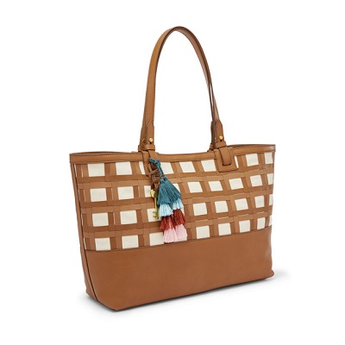

Rachel Tote

PRODUCT DETAILS

**Silhouette: Tote**

**Tech Compatibility: 13" Laptop**

**Exterior Material: Leather, 100% Cotton Canvas/Leather, Polyurethane Trim**

**Interior Details: 1 Zipper Pouch**

**Measurements: 14.75"L x 4.5"W x 11"H**

**Handles/Straps: 2 Handles**